Verifying if master is in a clean state

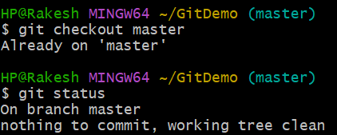

Listing all available branches

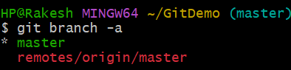

Pulling latest updates from remote

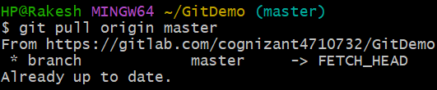

Pushing all pending changes to remote

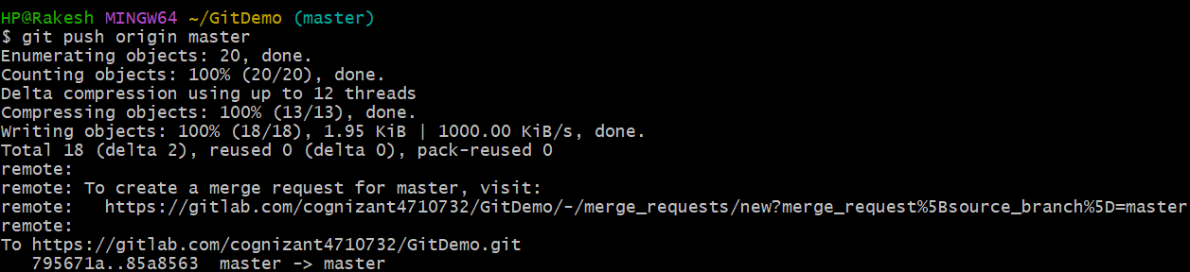

Confirming in GitLab

